- Challenge Name and Category: Undo (general skills)
- Difficulty/Points: Easy
- Description: Can you reverse a series of Linux text transformations to recover the original flag? Start searching for the flag here nc foggy-cliff.picoctf.net 54129
- Flag: picoCTF{Revers1ng_t3xt_Tr4nsf0rm@t10ns_72088a35}
- Solution/Walkthrough: Step 1 was to decode the current flag with the command base64 -d. Base64 identifies the encoded flag while -d is the function used to decode. Step 2 is to reverse the text. To do this we will input the rev function which reverses the text. Step 3 is to replace underscores with dashes. This is done by using the tr function to translate or delete characters from the standard input and rewrite the result in the output. Step 4 utilizes the same function except we are replacing parenthesis with curly brackets. Step 5 is the final and most confusing step. Here the current flag is encrypted in Rot13. This is an encryption method that alters the letter in question 13 places forward into the alphabet. This is done by utilizing the tr function yet again. tr 'a-zA-Z' 'n-za-mN-ZA-M' will decode the Rot13 flag recovering the original flag.
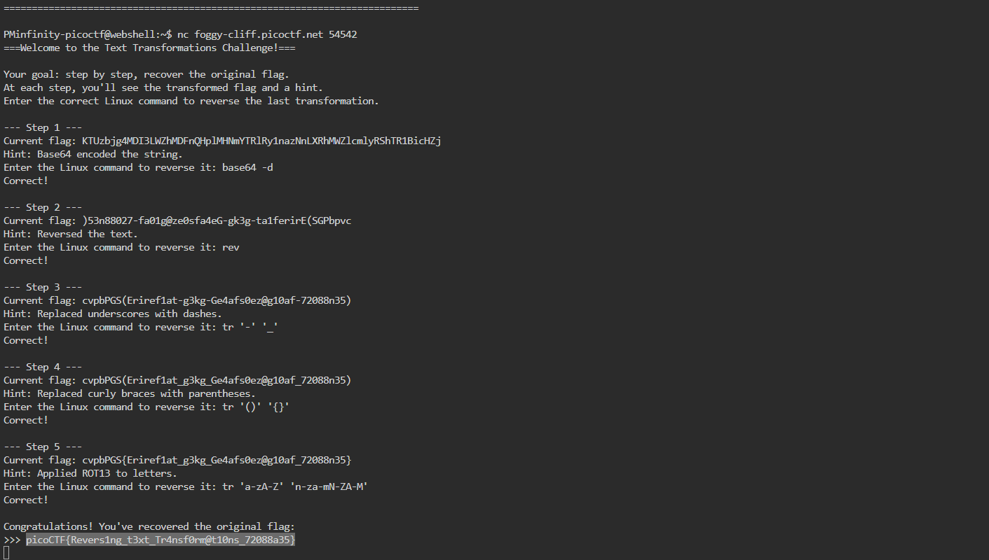
- Tools Used: Google, Web Shell
- Initial Reconnaissance: Following the hints I needed to obtain the functions to repeatedly reverse the flag back to its original state.
- Hypothesis Formulation: As with the initial recon I would follow the hints
- What Worked vs. What Didn't: At first, I was trying to reverse without using the Linux command. I quickly found that that format was not allowed so I had to dive into the proper commands. I overreached here by attempting way more complex commands than what I required. After several attempts I narrowed it down and discover the proper functions.

